

Assistant Director – Housing
Role Profile
Reports to:  Salary: | Director of Housing and Communities  £81,174 - £89,956 per annum
Location | West Offices, York and Hybrid working

- PURPOSE OF THE JOB
Lead the Housing workforce, develop and deliver the council’s housing strategies and services in order to:
- discharge its statutory housing functions including homelessness, allocations, private sector housing, housing adaptations, home energy efficiency in addition to the statutory requirements in relation to delivery of landlord services to council homes; and
- deliver its housing development programme.

- STRUCTURE
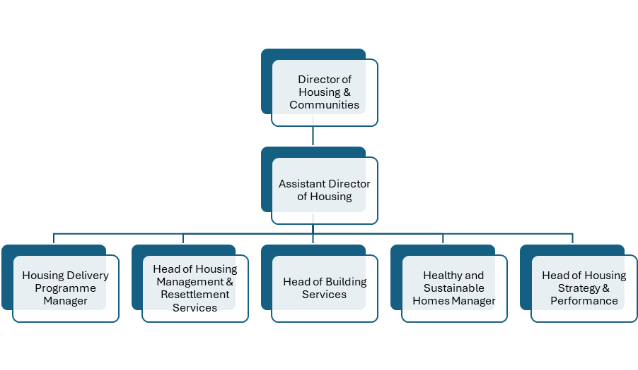
- Principal Accountabilities

- Inspire and lead the Housing workforce which include:
  - Housing Delivery
  - Housing Strategy and Partnerships
  - Housing Registration & Options
  - Resettlement Services
  - Temporary Accommodation
  - Building Services Responsive Repairs
  - Private Sector Enforcement
  - Housing Standards & Adaptations

- Set performance targets and manage development of monitoring and recording systems to measure and review the effectiveness of delivery of key objectives to meet housing strategy and standards set by the Housing Regulator, reflecting local, regional and national aspirations.
- Lead the formulation of strategy for all housing provision within the city including services provided by the council, other landlords and private sector provision to create sustainable housing options for the whole population.
- Monitor, identify and respond to external and political environments to ensure strategic plans in relation to Housing, meet the council’s objectives/council plan, the administration’s political ambitions alongside regional devolved and national government /statutory requirements.
- Ensure the council’s overall strategic ambitions in these areas fit with and are incorporated into the council’s overall objectives and main direction of travel.
- Lead the development of, plan and put in place shared programmes with key partners to:
  - provide and extend the range of housing provision within the city to meet future and existing needs.
  - promote and enforce high quality housing standards across all sectors in the city reflecting the council’s ambition to ensure that York is a great place to live.
  - reduce the incidents of homelessness.
- Oversee the management and maintenance of the council’s housing stock so that the housing stock is well maintained, creates sustainable tenancies, and provides a safe home and neighbourhood.
- Annually review and agree a set of meaningful and stretching performance measures which reflect local aspirations and are consistent with the operating environment.
- Monitor and review key performance measures to drive improvement and identify the need for new or mitigating actions.
- Benchmark performance against industry standards and best in class.
- Direct, lead and manage the performance of people, finance, assets across the Housing functions including effective management of the Housing Revenue Account and Business Plan.
  - Brief Chief Operating Officer, Director, Executive and elected members on performance against strategic and delivery plans and act as Principal Advisor for the discharge of the council’s statutory housing functions. Provide professional advice, to help inform decision making and governance arrangements around those responsibilities.
  - Use innovative, creative thinking to build relationships, influence and negotiate complex contentious issues and develop, support and promote a strong results driven and customer focussed performance culture ensuring the provision of cost-effective, efficient, high quality services in line with identified needs
  - Develop engagement strategies that enable local communities to get involved in redesign of services and identify new methods of delivery.
  - Work closely with national government agencies, (including the Ministry of Housing, Communities and Local Government, and Homes England and Housing Regulator) and professional bodies to capitalise on funding opportunities, keep abreast of the latest thinking and raise the profile of York.
  - Work with the statutory Children’s and Adults Corporate Directors to develop housing strategies for vulnerable people including pathways to reduce homelessness and rough sleeping.
- As part of the Council’s leadership group and departmental management team contribute to the effective direction, planning, performance of the service, directorate and Council.
- Work with the Assistant Director (Customers, Communities and Inclusion) to deputise for the Director in all aspects of their role.

additional informatioN

- This job is a politically restricted post as defined by the Local Government and Housing Act 1989.
- The postholder, along with City of York Council will be committed to ensuring equality, diversity, and inclusion among our workforce, and eliminating unlawful discrimination. The aim is for our workforce to be truly representative of all sections of society and our customers, and for each employee to feel respected and able to give their best. In providing goods and/or services and/or facilities the postholder will also ensure that there is no unlawful discrimination of customers or the public.
- This role is part of the emergency planning rota and the postholder is on call for out of hours emergencies.
- This role is an Information Asset Owner and must carry out the responsibilities of an Owner as required and set out in the Council’s ‘Information Governance/Data Protection Roles and Responsibilities Rules’.
- The postholder will take every opportunity within their role to be the best corporate parent they can be to support the City’s Looked After Children and Care Leavers, through ambitious, innovative and creative advocacy.

Assistant Director of Housing
Person Specification

Knowledge Skills & Experience

Qualifications
1 | A professional qualification at degree level or equivalent in a relevant subject and management qualification.
2 | Membership of relevant professional body or equivalent experience alongside the ability to study for the recognised professional Housing qualification soon to become mandatory by the UK government.
Essential Experience
3 | Successful track record of achievement as a senior leader in a housing environment in delivering service improvements.
4 | Significant experience of strategic planning and implementation, policy development and management in a Housing environment in a local authority, major independent service organisation or equivalent.
5 | Proven track record of effective financial and workforce management.
6 | Experienced in developing and implementing culture change strategies within a large diverse organisation.
7 | Ability to navigate successful outcomes in a political environment and build successful relationships with Portfolio members, and also ward councillors in their localities.
Essential Knowledge
8 | Substantial knowledge of the national policy context, regulatory environment, financial legislation and key issues relevant to the Housing Service.
9 | A clear understanding of the workings of local government and the current issues to be faced in a diverse unitary authority particularly the financial, legal and political context of public sector management.
10 | Knowledge of project management including business planning.
11 | An excellent understanding of policy formulation and implementation.
12 | Knowledge/experience of current best practice standards in the housing field both at local and national level.
Essential Skills
13 | Strong people management skills and leadership qualities including the ability to inspire develop and motivate others towards a common goal.
14 | Excellent communication skills both verbal and written.
15 | Strong negotiation and influencing skills.
16 | Active listening skills, being open to feedback and willing to learn.
17 | Budgetary management skills including the ability to co-ordinate, monitor and review financial resources, evaluating competing budgetary priorities and establish effective performance measures.
18 | Business planning and ability to develop, communicate and secure ownership of a clear vision and direction.
19 | Proven ability to develop practical and creative solutions to the management of strategic issues, resolves problems creatively, pragmatically and flexibly.

