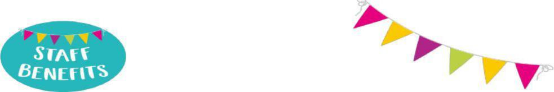
Benefits of working for City of York Council (CYC)
Annual leave
Chief Officers annual leave entitlement is 30 days holiday, rising to 35 days after 5 or more years of local government service, plus public holidays (usually 8 days per year). This leave is pro rata for part-time employees).
An additional 5 days paid leave per year is applied for employees to become a foster carer, settling in a new child, training courses, support groups, meetings and emergencies.
Employee learning and development
A key part of our Workforce Strategy is to support the continuous learning and development of all our
staff and offer a wide range of internal online and face to face training opportunities including coaching.

Relocation support
New staff may be eligible to relocation assistance if they live beyond a reasonable daily commuting distance of their new employment, requiring them to move home closer to their work base and where relocation assistance has been approved for the job they have been offered. This is subject to meeting the Relocation Assistance Policy eligibility criteria. Further details are available on request.

Travel to work support
- Car leasing scheme - Provides a cost-effective way for permanent CYC employees to lease a brand-new car via salary sacrifice. Please note: This scheme is not available to staff in schools.
- Cycle loans - via Salary Sacrifice - A loan is available to purchase a new bike, with essential accessories.
- Discounted bus tickets - discounted tickets via M-tickets app from First Buses for travel on the First Bus network.
- Discounted train travel – option to buy a discounted season ticket and pay for this over 12 equal instalments or purchase flexi travel tickets from Northern rail direct.
Employee wellbeing scheme
This service offers both practical and emotional support to help manage any of life’s challenges and difficulties, both great and small, whether they are for personal or work-related concerns. Includes 24-hour access to confidential counselling service plus cancer, smoking, alcohol and drug misuse support.

Benefits of working for City of York Council
Family Friendly Leave
We have a variety of leave options including dependent care leave, shared parental leave, maternity
leave, paternity leave and adoption leave.
Smart Working
Our award-winning headquarters in the centre of York, West Offices, operates as a flexible working environment and provides a safe, clean space with fully flexible ergonomic workstations, drop in zones, rest areas, and break out spaces, quiet areas encouraging a healthy work-life balance.
Pension
Employees are automatically enrolled in the Local Government Pension Scheme (LGPS), a defined benefit scheme This is one of the largest pension schemes in the UK. It is a defined benefit pension scheme which means your pension is based on your salary and how long you pay into the Scheme. Your pension is not affected by how well investments perform. The LGPS provides you with a secure and guaranteed income every year when you stop working. Employees have the option to opt out of the scheme.
Additional Voluntary Contribution scheme
When you join the Local Government Pension scheme you will have access to the salary sacrifice shared cost AVC scheme. This is a valuable employee benefit and offers you a cost-efficient way to top up your pension scheme.
Reward and Recognition
- Employee/Team of the Month – The CYC Staff Lottery Employee/Team of the Month' awards aim to celebrate individuals at the council who are doing an exceptional job. Colleagues and managers can nominate those who think are due extra recognition.

Benefits of working for City of York Council
CYC Clubs
Various Lottery funded clubs to join and meet other staff, e.g., golf society, reading and a knitting club.
Courses - Vocational and non-vocational adult learning courses
25% off adult education courses offered through York Learning.
Access to join the CSSC scheme and take advantage of a range of discounted sporting activities, days out, shopping, and much more.
Eye tests and glasses for Display Screen Equipment
CYC pay for the cost of an eye test up to £30. If relevant will also contribute £60 towards the cost of a
pair of spectacles.
GymFlex scheme via Salary sacrifice.
Join a gym in your local area and spread the yearly fee with monthly deductions from payroll.
Health cash plan
Take advantage of the discounted rates, extra benefits and claim money back towards everyday health
treatments and access to virtual health services for you and your family.
Home Electronics scheme via Salary sacrifice.
The biggest range of tech equipment and other goods to purchase. Spread a loan up to £3,000 over
monthly deductions from payroll.
Local discounts
Various local cafes/bars/restaurants offer discounts to CYC staff.
Staff lottery
For £2 a month, you could win £1,000 every month or one of seven other cash prizes.
Vivup - Your one stop shop for all staff benefits including salary sacrifice schemes for purchasing bikes, home tech and gym membership. Vivup offers a range of employee benefits and discounts from everyday shopping to cinema trips, holidays and larger purchases.

