Job Description

Business Area | Property
Post Title | Capital Manager
Grade | 11
Reports To | Property Project Manager
Date of Issue | April 2026

Job Purpose

The postholder will effectively and efficiently support projects through the provision of commercial activities in the pre and post tender phase of projects. The postholder will actively liaise with clients to provide programmes of works and also programmes of activities for individual schemes.

Structure chart

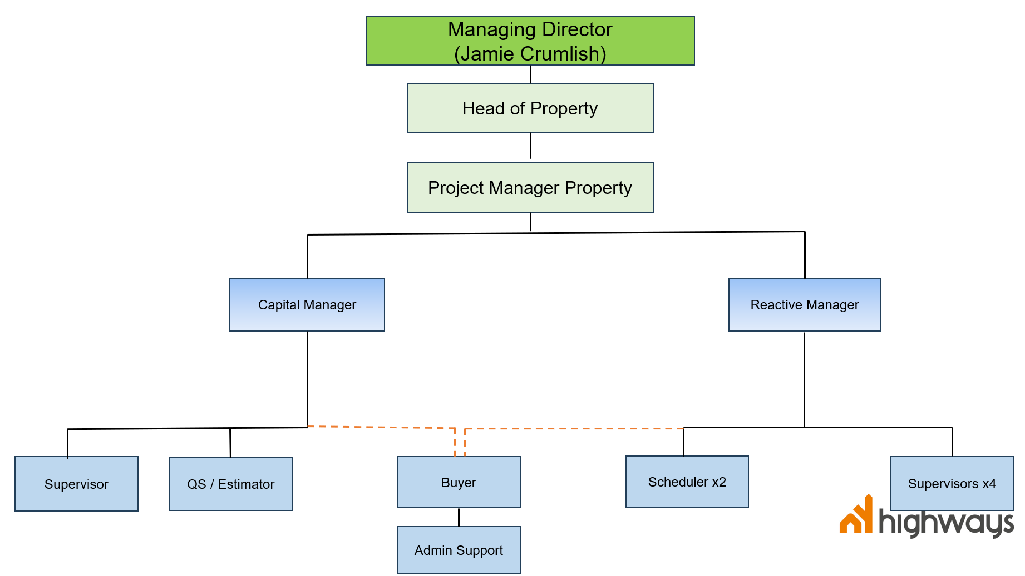

Main Duties and Responsibilities

- Ensure that projects are managed effectively in line with NYH’s governance, policies and procedures.

- Provision of support and advice to the property team including the Reactive Works Manager and Property Project Manager.

- Deputise for Property Project Manager as necessary.

- Provision of accurate and timely commercial reports and advice to the Property Project Manager and Head of Property.

- Serve as the main point of contact for clients and stakeholders throughout the project lifecycle.

- Creating and managing contracts in conjunction with the NYH/NYC Property teams and report against the appropriate commercial, performance, quality and KPI targets.
- Create annual programmes of work with a total value in excess of £10m to ensure all identified schemes are delivered within the financial year, and where necessary are programmed to span financial years.

- Ability to evaluate Risk and establish when schemes are to be delivered “in-house” as Principal Contractor and when schemes should be awarded to external suppliers for them to act as Principal Contractor.

- Able to procure and appoint multiple contractors for the delivery of schemes, able to plan and co-ordinate the different trades/companies to ensure a smooth and efficient delivery programme, some programmes will have very tight timelines (schools work throughout the summer holidays) and the postholder will need to demonstrate strong organisational skills along with being able to effectively prioritise workloads.

- Be able to understand and interpret scheme documents that may involve detailed and complex activities.

- Develop continual improvement of processes and procedures to ensure the company can demonstrate Value for Money (VfM).

- Check and audit processes and procedures for both company and statutory legal requirements.

- Identify, allocate and monitor resources in order to achieve goals.

- Prioritise and schedule objectives so as to optimise time, cost and quality.

- Contribute to the supply chain procurement and management.

- Develop and maintain strong working relationships with colleagues in all areas, suppliers and customers to ensure procurement processes and existing contracts are managed well and continue to deliver value for money.

- Administration of contracts and/or subcontracts including payment mechanisms and change procedures.

- Resolution of contentious issues, dispute resolution, final accounts agreement and management.

- Effective use of a variety of programmes for monitoring/managing the works and to support budget and risk management.

- Involvement in the production of project trading accounts/reports illustrating profit/loss, overhead cost recovery and financial outturn forecasts for management purposes.

- Ensure the application of contractual and statutory requirements for the applications for payment.

- Preparation, presentation, negotiation and agreement of interim and final accounts, including re-measurement in accordance with a standard method of measurement.

- Preparation and evaluation of compensation event claims, and/or other claims based upon contractual entitlement, and/or insurance claims.

- Inspire and motivate others through the use of appropriate leadership style to suit the team and situation.

- Assessment of costs against revenue. Robust analysis of contractors applications to ensure value for money is achieved during construction.

- Cost forecasting; management and control processes including the use of contract programmes, risk log, early warning and compensation event registers.

- Understand and deal with the causes of delay and disruption and understand the impact this may have on project completion.

- Ensure appropriate use of Bills of Quantities, Schedules of Rates, and Activity Schedules and their preparation in accordance with standard methods of measurement.

- Assign, considering all risks, the correct NEC pricing option A-E to a scheme.

- Create a schedule of rates for the use of contractors/sub contractors and ensure, where possible, ’back to back’ contracts are utilised.

- Identify, allocate and monitor resources in order to achieve goals.

- Prioritise and schedule works in order to optimise time, cost and quality.

- Mentor, develop and supervise other less experienced members of the team.

- Ensure that the PDR process operates effectively within your team and that end of year and quarterly reviews are completed and submitted within the NY Highways timescales.

- Manage your team in line with all the NY Highways policies and procedures and ensure that employees are aware of their obligations under these.

- Fulfil your health and safety management role as detailed in the NY Highways Health and Safety Policy, organisational statements, and procedures to ensure a safe working environment for yourself, members of your team and others who may be affected by your team’s activities.

- Work in line with all NY Highways policies and procedures and be aware of the obligations for employees under these.

- Behave according to the Employee Code of Conduct and be aware of employee responsibilities under the Code.

- Behave according to the Behaviours Framework.

- Comply with health and safety policies, organisational statements and procedures, report any incidents / accidents / hazards and take a pro-active approach to health and safety matters in order to protect oneself and others.

- Undertake any other duties of a similar nature that may be required from time-to-time.

Person Specification

Criteria No | Criteria Description | Essential (E) | Desirable (D)
Qualifications & Education
 | Bachelor’s degree, or equivalent qualification in Quantity Surveying, Civil Engineering, Construction management, financial management, Business or Project management (or other equivalent related discipline) |  | D
 | Working towards or prepared to work towards professional membership of appropriate organisation (i.e. RICS/CIOB/ICES) |  | D
Knowledge & Experience
 | Previous proven experience managing projects in the Property, Civil Engineering, Building and Construction Industry, with a proven track record of delivering projects on time and within budget | E
 | Sound knowledge of standard forms of construction contracts, notably NEC & JCT. | E
 | Experience of and ability to find positive solutions to complex problems. | E
 | Experience managing performance and outputs in line with department and project specific budgets | E
 | Understanding and awareness of good customer service principles and practice. | E
 | Understanding of company accounts, including turnover, profit/loss, work in progress and cash-flow. | E
Skills
 | Ability to work and communicate effectively with colleagues and stakeholders and other departments. | E
 | Excellent IT skills and good understanding of MS Office packages. | E
 | Ability to manage multiple projects simultaneously and adapt to changing priorities | E
 | Excellent communication skills both verbal and written | E
 | Persuasion and influencing skills |  | D
Personal Attributes
 | Minimum level of everyday behaviour as set out in the company behaviours matrix | E
 | Strong Leadership and management skills | E
 | Excellent organisational and time-management abilities | E
 | Maintain good internal and external relationships with Clients, customers, member, colleagues and contractors. | E
 | Advanced problem-solving and decision-making abilities | E
 | Strong analytical skills and attention to detail | E
Other Requirements
 | Full driving licence and use vehicle to allow travel to our sites across North Yorkshire | E

