Job Title: | Head of IT
Reports to: | Executive Director
Grade: | SLT1c
Date: | January 2026

1. Job Purpose
The Head of IT will lead the strategic direction, development, and delivery of all technology services across the organisation. This role is pivotal in driving digital transformation, ensuring robust IT infrastructure, and aligning technology initiatives with public service goals. The postholder will champion innovation, resilience, security, and accessibility in technology to enhance business performance.
The Head of Technology will be a key voice in executive decision-making, guiding the organisation through a period of digital transformation.

This role will develop and implement a forward-looking IT strategy aligned with organisational priorities and public sector mandates. This involves directing and managing all IT operations to meet both internal and external customer requirements.

2. Organisational Structure
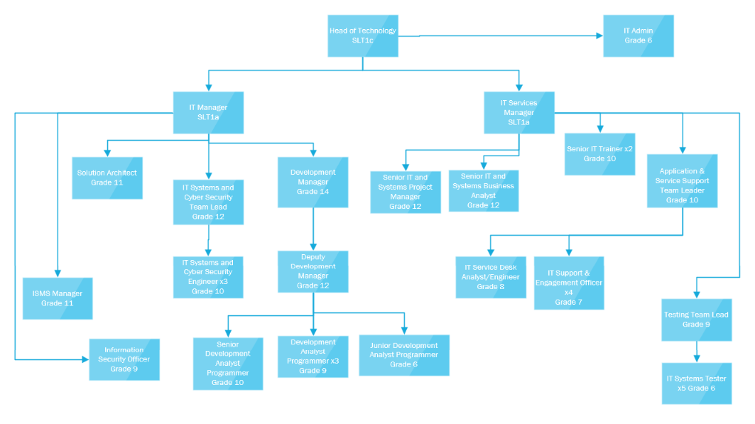
3. Dimensions
The post holder has responsibility for all members of staff within IT Department with a headcount of circa 35.

The Head of IT will be responsible for managing the department budget of c. £4m

Responsible for delivery of projects with an investment budget of between £2-3m over the next 3 years.

This role will be responsible for ensuring that IT is well managed and supports the delivery of all IT projects on time and in budget, collaborating and co ordinating with the wider project portfolio . Providing challenge to the organisation at all levels to ensure there is always a clear strategy with appropriate resources made available to deliver this plan and benefits realised.

The Head of IT will be responsible for a clear strategy on system health incorporating a plan of continuous improvements for future proofing business critical systems. Advising the Board to enable very clear direction to the IT team on where they need to develop detailed delivery plans and commit resources.

4. Principle Accountabilities
Strategic Leadership & IT Vision
• Develop and implement a forward‑looking IT strategy aligned with organisational priorities, public sector mandates, and Board direction.
• Create and maintain a technology and infrastructure roadmap with emphasis on digitalisation, AI, cyber security and long‑term capability building.
• Contribute to organisational strategic policy and decision‑making as a member of the Senior Leadership Team (SLT).
IT Operations & Service Delivery
• Lead and manage all IT teams to ensure secure, reliable, scalable, and high‑quality IT services.
• Balance day‑to‑day operational stability with mid‑term improvements and long‑term strategic development.
• Ensure all IT work is delivered on time, within budget, and to agreed quality standards.
• Establish and maintain robust processes and procedures for consistent, secure, high‑quality service delivery.
Digital Transformation & Innovation
• Support and drive digital transformation programs that enhance service delivery, efficiency, and user experience.
• Promote innovation and continuous improvement across IT systems, services, and processes.
Governance, Compliance & Security
• Ensure compliance with data protection, cybersecurity, accessibility standards, and relevant UK/EU legislation.
• Uphold strong corporate governance within the Technology and IT function.
• Provide professional and technical advice on IT and technology matters.
People Leadership & Performance Management
- Provide leadership, vision, and direction to the IT/Technology team.
• Set clear objectives, manage performance, and support staff development and training.
• Foster a culture of equality, inclusion, collaboration, and high performance.
Stakeholder, Supplier & Partner Management
• Manage key relationships with public sector partners, suppliers, and service providers to maintain a reputation for IT excellence.
• Ensure effective communication of IT strategies, objectives, and policies across the organisation.
• Build strong working relationships with colleagues and stakeholders to ensure effective cross‑functional collaboration.
Change Management & Organisational Development
• Lead organisational development and change initiatives related to technology.
• Act as a change champion, ensuring clear communication and progress reporting to stakeholders, including Board and SLT.
Financial & Resource Management
• Manage and monitor the IT budget, ensuring efficient and effective use of financial resources.
• Ensure systems and processes integrate effectively with other business functions.

Continuous Improvement & Professional Development
• Stay up to date with relevant training, industry developments, and best practices.
• Ensure services are delivered in line with legislation, organisational objectives, and policies (including Equality & Diversity, Customer Care, and Health & Safety).
Other Responsibilities
• Undertake additional duties as required that fall within the scope and grade of the role.

5. Planning and Organising
The role will play a key part in the strategic planning for the business over a 3 to 5 year horizon and will lead the strategic planning for IT.
The role holder must have the ability to plan and structure work to achieve service objectives, setting realistic timescales when planning, anticipating problems and developing contingency plans. This will include annual business planning and input into a rolling 3 year workforce plan.
The role holder must be able to monitor and manage the performance of services, systems, and individuals against standards and outcomes.
The role holder must take personal responsibility for achieving results and take immediate action to address under performance.

6. Decision Making
The Head of IT will have full responsibility for delivery within the agreed business plan objectives.
Any decisions impacting upon the strategic plan would be escalated to the Operations Director and the Board with recommendations made accordingly

7. Internal and External Relationships
All Staff across YPO
Directors and senior officers within YPO, of lead authority and member authorities.
Government departments, public bodies, suppliers, customers.
Extensive external relationships with suppliers and trade bodies, including outsourced partners providing Hardware/Network Engineering & Support, ERP/Finance Software development and support, eCommerce development and support.
8. Knowledge, Skills and Experience
Area | Essential | Desirable | Assessment
Qualifications
Relevant Degree in a related subject or substantial equivalent demonstrable experience in a similar environment | X |  | Application/Interview
Evidence of post-graduate and/or continuing professional development in relevant area | X |  | Application/Interview
Process improvement training and/or project management e.g. MSP (Managing Successful Programmes) Practitioner |  | X | Application
Knowledge
Knowledge of the principles of understanding strategy and strategic thinking | X |  | Application/Interview
Knowledge of best practice programme management techniques | X |  | Application/Interview
Knowledge of IT strategy formulation and implementation using timebound, clear project plans within large complex businesses | X |  | Interview
Knowledge of Infrastructure (Hardware, networks, phone systems, access control), software systems and data/Management Information Reporting so you can lead from a point of knowledge | X |  | Application/Interview
Knowledge of data capture and reporting mechanism | X |  | Application/Interview
A strong understanding of business processes and needs along with programme management and running a successful Technology/IT team within a commercial organisation | X |  | Application/Interview
A strong understanding and knowledge of cyber security, security frameworks and best practice including Cyber Essentials and ISO 27001. | X |  | Application/Interview
Skills
Drive to achieve results | X |  | Application/Interview
Ability to understand and analyse technical and programme issues | X |  | Interview
An ability to visualize and build a strategy with a proven track record to deliver this through a structured team | X |  | Interview
Ability to secure the benefits of projects and programmes | X |  | Interview
Working collaboratively | X |  | Application/Interview
Strong demonstrable influencing skills with senior stakeholder groups | X |  | Interview
Understanding strategy and strategic thinking with the ability to then turn these into deliverable, time bound plans | X |  | Application/Interview
Strong understanding of Data capture and reporting mechanisms to drive the MI function and support KPI reporting. | X |  | Application/Interview
Experience of moving a business to more digital sales channels |  | X | Interview
Experience
Track record of leading the IT & Technology function within a commercial organisation, including leading strategic IT development projects and introducing AI | X |  | Interview
Experience of visualising and forming a strategic plan for the business – taking input from key business stakeholders of what the business requires | X |  | Interview
Experience of managing Programme and Project risk | X |  | Application/Interview
Experience of managing multiple, competing priorities simultaneously in a fast moving logistics environment | X |  | Interview
Experience and proven ability in Stakeholder Management | X |  | Application/Interview

9. Special Features
Out of hours work may be necessary at this level within the organisation.

Jobholder Signature:
Manager Signature:
Date:

