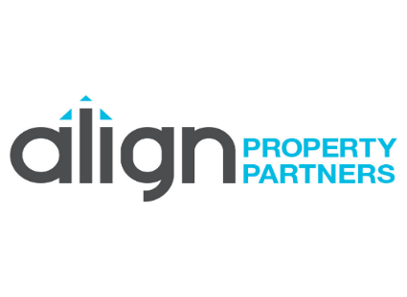
Title: Head of Architecture
Responsible to: Managing Director as part of the Senior Management Team
- Role purpose: The Architect Director will be responsible for developing client relationships that secures new and long terms business. Will lead, manage and motivate the architectural team, to execute their duties by creating a clear vision with shared goals in a positive and dynamic business environment. Oversee technical delivery and financial accountability of Architectural team within the multi-discipline organisation,
Accountabilities:
- Provide highly visible leadership, management and direction in a manner consistent with the Align Property Partners (APP) core values.
- Responsible for identifying and developing new area’s and sectors of work and actively developing those new income streams and contribute to the achievement of business growth plan objectives and targets.
- Effectively assess team and individual strengths and development needs, putting in place appropriate actions / learning requirements to achieve excellence
- Effective project manager with shared strategic leadership across APP, being a pivotal member of the Senior Management Team within a multi-disciplinary design consultancy.
- Deliver a quality design service for all projects that meets or exceeds customer expectations.
- To actively contribute to the annual Business Plan for review and approval by the Board, and working with the Management Team to achieve set goals, on technical delivery, quality and financial performance,
- Actively contribute to APP plan to become BIM Level 2 accredited.
- Lead and manage the delivery of a design review service across multi-disciplines, maintaining and promoting high standards of design, construction and contract management and promote Sustainable Design across the team, and within projects wherever possible.
- Provide active support to the business in the management of key customer relationships,
- Support local and national sales and bids as appropriate.
- Set objectives for the architectural team members, appraising their performance annually,
- Inspire a culture of excellence and continuous improvement, ensuring the delivery of demonstrable high quality products and services which embrace quality standards.
To succeed in this role you will:
- Hold RIBA Chartered Status or similar
- Hold an Architectural degree and postgraduate qualification
- Substantial post qualified experience, 10+ years
- Be able to professionally network
- Exceptional experience in working in private practice with knowledge of public sector process.
- Experienced Team Manager and inspirational leader
- Awareness and commitment to the use of digital production techniques including Autodesk Revit & AutoCAD and NBS software.
- Solid working knowledge across all sectors or the RIBA Plan of Work.

