

**Role Profile**

|  |  |
| --- | --- |
| **Job Title:**  **Directorate:** | Assistant Director of Housing  Housing & Communities |
| **Reports to:** | Director of Housing & Communities |
| **Date:** | October 2024 |

1. **PURPOSE OF THE JOB**

Direct and manage the council’s housing strategies and services in order to:

* discharge its statutory housing functions including in relation to homelessness, allocations, private sector housing, housing adaptations, home energy efficiency in addition to the statutory requirements in relation to delivery of landlord services to council homes.
* deliver its housing development programme.

1. **DIMENSIONS**

|  |  |  |
| --- | --- | --- |
| Revenue income £54,500,000  Revenue expenditure £52,139,200  3 year Capital expenditure £83,526,200  Direct Report 2  Indirect Reports 290 FTE |  |  |

The specific areas of responsibility include the following:

* Housing Registration & Options
* Resettlement Services
* Temporary Accommodation
* Building Services Responsive Repairs
* Private Sector Enforcement
* Housing Standards & Adaptations
* Housing Delivery
* Housing Strategy & Performance

1. **PRINCIPAL ACCOUNTABILITIES**

* Lead the formulation of strategy for all housing provision within the city including services provided by the council, other landlords and private sector provision to create sustainable housing options for the whole population.
* Monitor, identify and respond to external and political environments to ensure strategic plans in relation to Housing meet the council’s objectives/council plan, the administration’s political ambitions alongside regional devolved and national government /statutory requirements.
* Ensure the council’s overall strategic ambitions in these areas fit with and are incorporated into the council’s overall objectives and main direction of travel.
* Lead the development of, plan and put in place shared programmes with key partners to:
  + provide and extend the range of housing provision within the city to meet future and existing needs.
  + promote and enforce high quality housing standards across all sectors in the city reflecting the council’s ambition to ensure that York is a great place to live.
  + reduce the incidents of homelessness.
* Oversee the management and maintenance of the council’s housing stock so that the housing stock is well maintained, creates sustainable tenancies, and provides a safe home and neighbourhood.
* Set performance targets and manage development of monitoring and recording systems to measure and review the effectiveness of delivery of key objectives to meet housing strategy and standards set by the Housing Regulator, reflecting local, regional and national aspirations.
* Annually review and agree a set of meaningful and stretching performance measures which reflect local aspirations and are consistent with the operating environment.
* Monitor and review key performance measures to drive improvement and identify the need for new or mitigating actions.
* Benchmark performance against industry standards and best in class.
* Direct, lead and manage the performance of people, finance, assets across the Housing functions including effective management of the Housing Revenue Account and Business Plan**.**
  + Brief Chief Operating Officer, Director, Executive and elected members on performance against strategic and delivery plans and act as Principal Advisor for the discharge of the council’s statutory housing functions. Provide professional advice, to help inform decision making and governance arrangements around those responsibilities.
  + Use innovative, creative thinking to build relationships, influence and negotiate complex contentious issues and develop, support and promote a strong results driven and customer focussed performance culture ensuring the provision of cost-effective, efficient, high quality services in line with identified needs
  + Develop engagement strategies that enable local communities to get involved in redesign of services and identify new methods of delivery.
  + Work closely with national government agencies ,(including the Ministry of Housing, Communities and Local Government, and Homes England and Housing Regulator) and professional bodies to capitalise on funding opportunities, keep abreast of the latest thinking and raise the profile of York.
  + Work with the statutory Childrens and Adults Corporate Directors to develop housing strategies for vulnerable people including pathways to reduce homelessness and rough sleeping.
* As part of the Council’s leadership group and departmental management team contribute to the effective direction, planning, performance of the service, directorate and Council**.**

1. **JOB CONTEXT**

The Assistant Director is responsible with colleagues and Council Management Team for ensuring strategic leadership during a period of ongoing change and transformation in the council. The postholder will work with the Assistant Director (Customers, Communities and Inclusion) to deputise for the Director in all aspects of their role.

The postholder will lead and manage the Housing Service to deliver an excellent, co-ordinated service, having overall responsibility for the management, maintenance and improvement of the Council’s housing stock, including its sustainability. You will ensure the housing needs of the region are assessed regularly, and that the Council has an up to date and fit for purpose housing strategy. The postholder will work closely with colleagues in Planning and City Development to support the Council’s wider ambitions on healthy development, place making and regeneration. In addition to delivering improvements and efficiencies across the range of services through innovation, applying good practice, workforce engagement and promoting a customer focus.

In addition to discharging the Council’s statutory duties in relation to Housing, the Assistant Director will build relationships and engage with partners in public and private sectors to deliver quality outcomes.

1. **IMPACT & INFLUENCE**

This role contributes to the development, articulation and communication of a clear vision for the development of key aspect of York as a successful city, and provides a framework to ensure an effective and shared programme of joined up strategy with key partners.

The job holder is in a position to identify opportunities which impact on the wider community to the benefit of all, it requires imagination and vision to see potential; to see how supporting projects can generate positive outcomes. Using their influence and networks to bring interested parties together to achieve these ends. The net benefit to the public is that York is a more affordable and prosperous place, making it a better place to live and work.

The job holder is responsible for seeking opportunities to develop the revenue of CYC through partnerships, new ventures and delivers activities that grow revenue and minimises cost without detriment to services. They also are instrumental in engaging and maximising investment from others in relation to the provision of Housing or related investment.

1. **OrGANISATION**

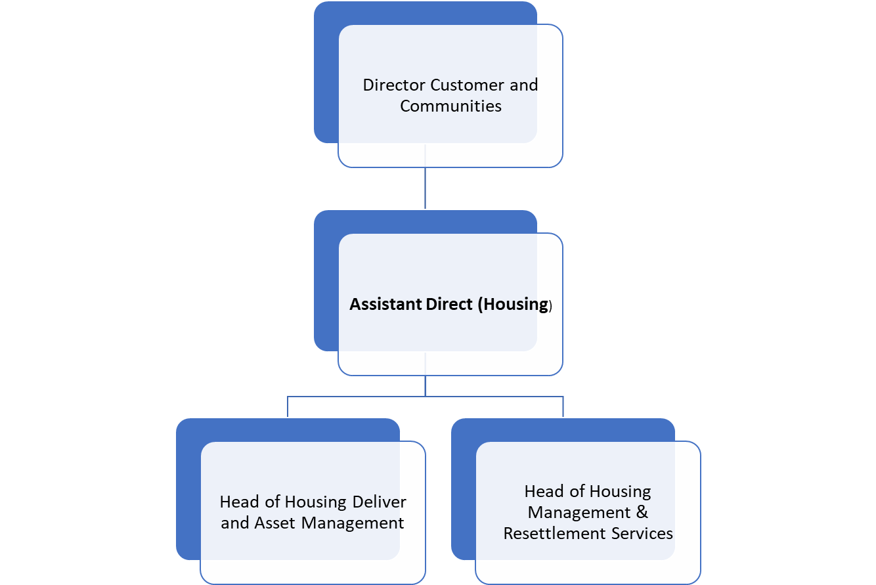

1. **COMPLEXITY OF THE JOB**

The postholder with significant autonomy and responsibility, will co-ordinate activities and priorities which impact on agreed outcomes for the service, directorate, council, city and region.

This will require use innovative, creative thinking to build relationships, influence and negotiate complex contentious issues and develop, support and promote a strong results driven and customer focussed performance culture ensuring the provision of cost-effective, efficient, high quality services in line with identified needs.

A requirement of the role is to maximise commercialisation of services provided, demonstrating strong commercial awareness and the ability to balance this alongside competing priorities.

1. **Knowledge Skills & Experience**
   * + - Substantial knowledge of the national policy context, regulatory environment, financial legislation and key issues relevant to the Housing Service.
       - A clear understanding of the workings of local government and the current issues to be faced in a diverse unitary authority particularly the financial, legal and political context of public sector management.
       - Significant experience of strategic planning and implementation, policy development and management in a local authority, major independent service organisation or equivalent
       - A successful track record of achievement at senior level in developing and implementing housing/property policies to achieve outcomes.
       - Knowledge of project management including business planning
       - An excellent understanding of policy formulation and implementation.
       - Proven track record of effective financial and workforce management
       - Knowledge/experience of current best practice standards both at local and national level.
       - Experienced in developing and implementing organisational culture change strategies within a large diverse organisation.
       - Professional qualification at degree level or equivalent in a relevant subject and management qualification.
       - Membership of relevant professional body or alternatively equivalent experience alongside the ability to study for the recognised professional Housing qualification soon to become mandatory by the UK Government.
       - Strong credible leadership with a passion for delivering improvement in services.
       - Excellent communication skills, strong negotiation and influencing skills and ability to effectively deal with the media.
       - Budget management skills to co-ordinate, monitor and review financial resources, evaluating competing budgetary priorities and establish effective performance measures.
       - Business planning and ability to develop, communicate and secure ownership of a clear vision and direction.
       - Takes ownership for informed decisions and delivering outcomes.
       - Development of practical and creative solutions to the management of strategic issues, resolves problems creatively, pragmatically and flexibly.
       - Ability to navigate successful outcomes in a political environment and build successful reletionshipds with Portfolio members, and also ward councillors in their localities.
       - Strong people management skills and leadership qualities including the ability to develop and motivate others.
2. **additional informatioN**

* This job is a politically restricted post as defined by the Local Government and Housing Act 1989.
* The postholder, along with City of York Council will be committed to ensuring equality, diversity, and inclusion among our workforce, and eliminating unlawful discrimination. The aim is for our workforce to be truly representative of all sections of society and our customers, and for each employee to feel respected and able to give their best. In providing goods and/or services and/or facilities the postholder will also ensure that there is no unlawful discrimination of customers or the public.
* This role is part of the emergency planning rota and the postholder is on call for out of hours emergencies.
* This role is an Information Asset Owner and must carry out the responsibilities of an Owner as required and set out in the Council’s ‘Information Governance/Data Protection Roles and Responsibilities Rules’.
* The postholder will take every opportunity within their role to be the best corporate parent they can be to support the City’s Looked After Children and Care Leavers, through ambitious, innovative and creative advocacy.