Job Title | Head of HR & People Services
Reports to | Executive Director
Grade | SLT1c
Date | November 2019 (revised 11 June 2024)
1. Job Purpose
Responsible for leading the development and implementation of the HR Strategy transforming the individual functions of HR, Talent Management, Business Services from transactional, reactive support services to ones that are dynamic and enabling.

The role holder is responsible for the achievement of organisational goals by ensuring that relevant and innovative people policies, practices and learning and development opportunities are in place so that the organisation can attract, retain and develop outstanding staff to function and continue to grow.

A key member of the Senior Leadership Team this role will provide professional and technical advice to the Board and Elected Members on legal and employment issues as well as best practice standards relating to HR and OD.
2. Organisational Structure
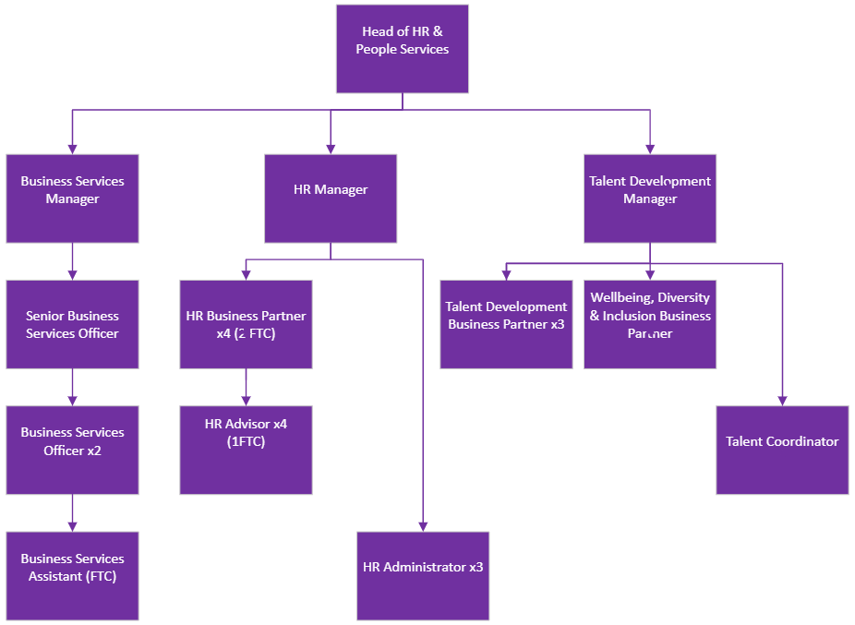

3. Dimensions
The role leads a team of 22 people, with 3 direct reports plus takes the lead pastoral care role for c25 apprentices and has overall HR and OD responsibility for circa. 536 employees.

Departmental budgets are c £3.6m)
4. Principle Accountabilities
Responsibilities
- Responsible for the development and implementation of the people strategy, delivering transformational change in areas such as organisational development and culture change.
- Responsible for managing a team of Talent Management specialists to design and deliver learning interventions across the business, allocating resource, managing performance and ensuring learning and talent management interventions are delivered to a high standard.
- Identifying areas for continuous improvement, making sure all services are at the forefront of innovation and excellence.
- To write reports, including making recommendations to YPO Board and presenting where required.
- To manage the trade union relationships locally for all employee issues.
- Leadership of the wider HR and People Services Teams, developing a reputation within the organisation of high performing teams who can support the delivery of quality services to meet the organisations targets for service delivery, efficiency and overall growth.
- To develop and deliver strategic objectives which will support the Board’s overall strategy direction for YPO.
- To provide responsive, consistent and professional, advice guidance and support with regard to all employee related matters.
- To develop appropriate policies and procedures in line with employment legislation that safeguards the organisation.
- To ensure a professional support service is provided to visitors, elected members and employees through the provision of a customer focused business support function.
- To lead an organisational development programme that will embed the YPO values and change the culture of YPO towards a more customer focused and performance driven organisation.
- Attendance at JCC and Health and Safety Committee Meetings as required.
- Accountable for the budgets for HR, Talent Management and Business Services ensuring that financial resources are deployed and managed effectively and efficiently.
- To ensure YPO complies with all legal obligations regarding employment, advising up to and including Elected Members.
- To manage and appraise through the setting and monitoring of performance targets and standards, to ensure they effectively achieve strategic aims and service plans, encouraging personal development, providing support and taking action as necessary.
- To maintain effective relationships with key partners, service providers, stakeholders and YPO customers.
- To lead and undertake work on special projects, policy priorities, plans and programmes as required by the Managing Director.
- To lead in the procurement of services, e.g. OHU Services in liaison with Contracts and Procurement teams.
- To work co-operatively with colleagues to ensure that the function operates consistently and effectively in the implementation and application of all departmental procedures and policies.
- To keep up to date with information, training and development opportunities appropriate to maintaining and developing professional service standards.
- Ensuring that services are delivered in line with relevant legislation, YPO objectives and policies including those relating to Equality and Diversity, Customer Care and Health and Safety.
- To undertake such other duties as may be required from time to time that reasonably fall within the scope and grade of the post.
5. Planning and Organising
- Responsible for creating and maintaining the long-term strategy in relation to people and property (typically 3-5 years) and presenting that to the board for agreement
- Responsible for developing and managing the annual business planning process for the functional areas, with a half year review process to support this.
- Responsible for planning own workload and that of the functional areas.
- Responsible for ensuring that an organisation structure is in place for the functional areas which are fit for purpose and has the necessary resources to support all of YPO’s activities.
- Required to work proactively with colleagues on the Senior Leadership Team to ensure that their own activities and resource plans support the business planning cycle.
- Responsible for creating a culture of continuous improvement within the functional areas, with constant review of systems and technology to ensure that YPO is operating in line with current industry best practice.
6. Decision Making
- Direct responsibility for operational decisions relating to day-to-day financial management of People Services.
- Responsible for advising Board and Elected Members as required.
- Responsible for setting priorities and managing relationships between several sub functions including makings decisions and recommendations up to and including Elected Members.
7. Internal and External Relationships
Internal:
- Significant contact with the Managing Director, Board Members, Elected Members.
- Day-to-day contact with all teams within YPO.
- Regular contact with internal Trade Unions Representatives.
External:
- Lead contact for lead authority relationships, apprentice providers and local schools and colleges.
- Senior executives of stakeholder organisations, strategic partners.
- Suppliers, e.g. OHU Services
8. Knowledge, Skills and Experience
Area | Essential | Desirable | Assessment
Knowledge
Chartered Institute of Personnel & Development qualified to MCIPD/ FCIPD | X |  | Application
Coaching and / or Mediation qualification |  | X | Application
- Detailed Knowledge of Employment Legislation relating to terms and conditions of employment | X |  | Application & Interview
- Detailed professional HR knowledge in relation to employee relations and conduct policies and procedures that support consistent employee behavior | X |  | Application & Interview
- Detailed knowledge of equality and diversity legislation in relation to employment | X |  | Application & Interview
A practical working knowledge of TUPE legislation | X |  | Application & Interview
Detailed knowledge of the NJC terms and conditions for Local Government |  | X | Application & Interview
Skills
Proven ability to build effective teams and relationships, which are not limited by organisational boundaries or hierarchies | X |  | Interview
Effective communication and interpersonal skills, with the ability to communicate appropriate to the audience | X |  | Application & Interview
Ability to provide visible and supportive leadership, to motivate and develop individuals to achieve their full potential | X |  | Interview
Ability to build, work and maintain effective relationships with Board Directors, Elected Members, key partners, service providers, stakeholders and YPO customers | X |  | Application & Interview
Adaptable in their approach to meet the needs of a diverse organisation and workforce | X |  | Interview
Experience
Budget and contract management experience | X |  | Application & Interview
Experience of developing the skills and competencies of others through appropriate development activities | X |  | Application & Interview
Experience of enabling self and team to identify and implement changes in work processes, styles and environments | X |  | Interview
Demonstrable experience of analysing and interpreting information from a number of sources to determine appropriate action | X |  | Application & Interview
Experience of writing and presenting business plans and reports at a senior level. | X |  | Application & Interview
Experience of managing a number of sub functions across a diverse workforce |  | X | Interview
Experience of providing employee relations advice, up to and including advising on discipline and grievance hearings | X |  | Interview

9. Special Features
As a Senior Leadership Team appointment this role requires a flexible approach and will involve travel away from the YPO head office in Wakefield, periods of overnight stays and unsociable hours.
The role requires adherence to tight working deadlines and a flexible approach to managing projects and information.
Jobholder Signature:
Manager Signature:
Date:

